CENWP-OD-B 04 July 2024

MEMORANDUM FOR THE RECORD

SUBJECT: 24BON017 MFR WA Shore LPS UMTJ RB2 Pacific Lamprey Mortalities
On the morning of 04 July, Project Biologists discovered one adult Pacific Lamprey mortality in Rest Box 2 of the Washington Shore Upstream Migrant Transportation Junction LPS (WA Shore UMTJ LPS RB2). The fish was scanned for PIT tags, inspected, and returned to the river.

- Species – Pacific Lamprey (Entosphenus tridentatus)
- Origin – Unknown
- Length – 64.77cm
- Marks and tags – None
- Marks and Injuries found on carcass – Fungus, no other marks or injuries.
- Cause and Time of Death – Unknown
- Future and Preventative Measures – N/A
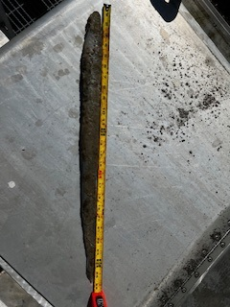
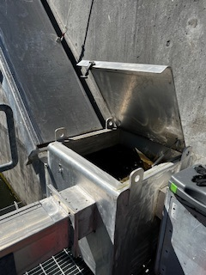

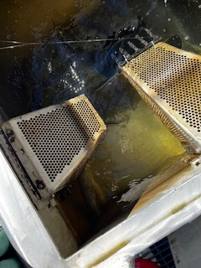

Sincerely,
Project Fisheries

